
NATIONAL UNIVERSITIES OF MODERN
LANGUAGES
FACULTY OF ENGINEERING AND COMPUTING
DEPARTMENT OF SOFTWARE ENGINEERING

Course Name: WEB-II
Assignment No./ LAB – Task /Project LAB 8: Working with React API fetch()
Date: 10 Oct, 2025
Submitted by
Class: BSSE (VII) Section - Sessions (M/A) Afternoon
Name: Zulqarnain hassan Roll No. Sp-21379
Submitted to
Instructor Name: Mr. Danish
To be filled by Instructor
Instructor Comments:
Marks Obtained: Total Marks:
CLO No. :

LAB 8: Working with React API fetch()
LAB TASK 1 — Fetch Data from API using mockapi.io

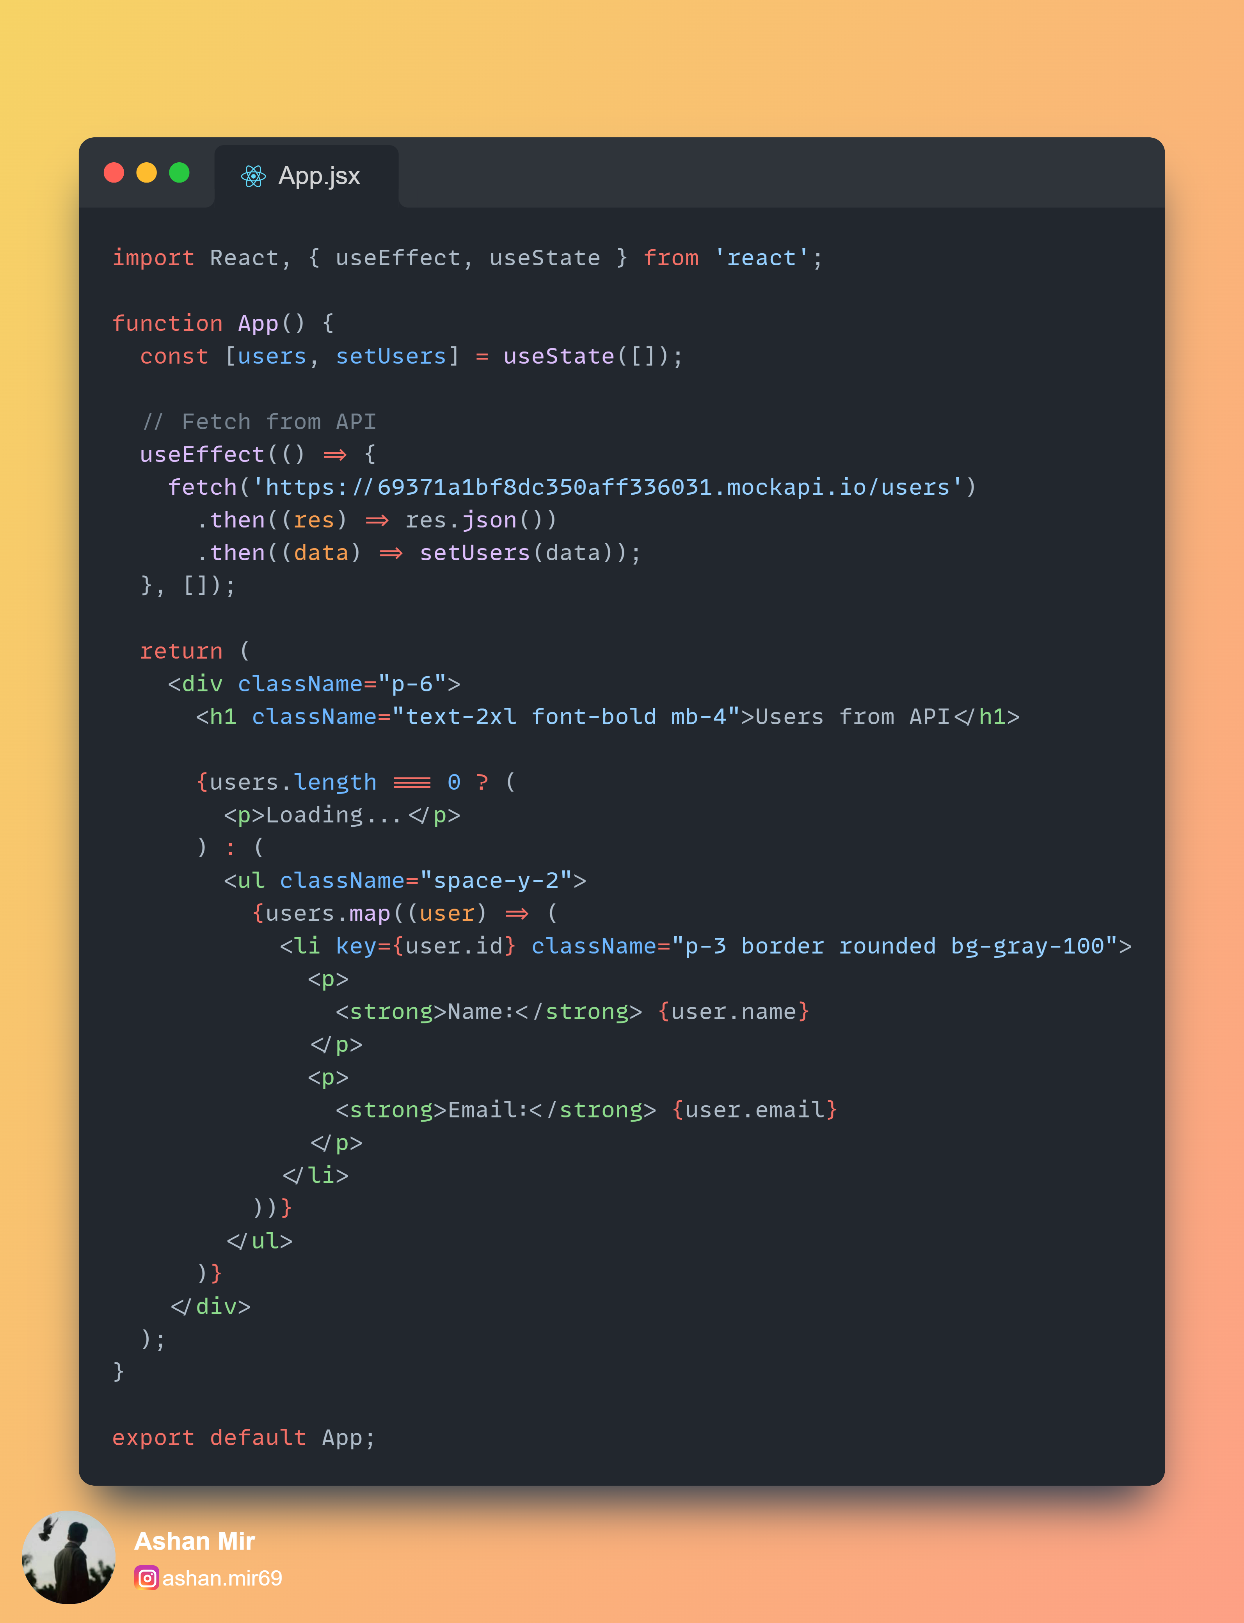
Output:

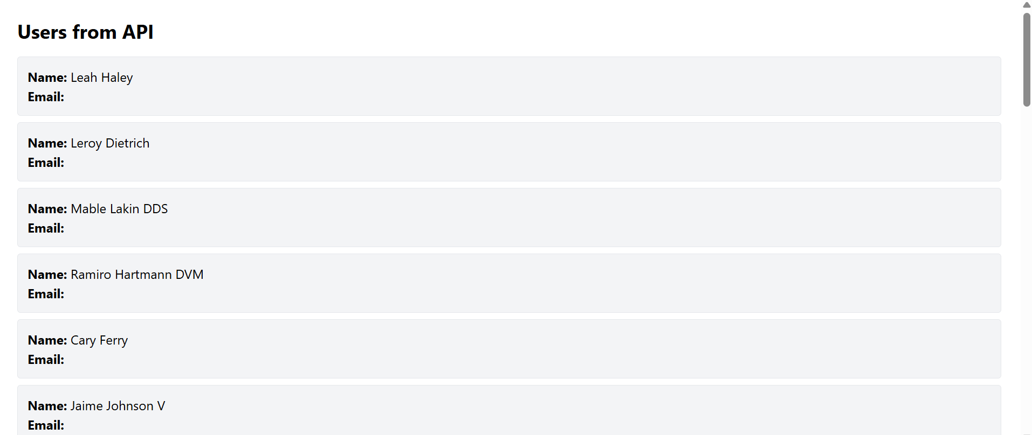

LAB TASK 2 — Countdown Timer using Hooks + useEffect

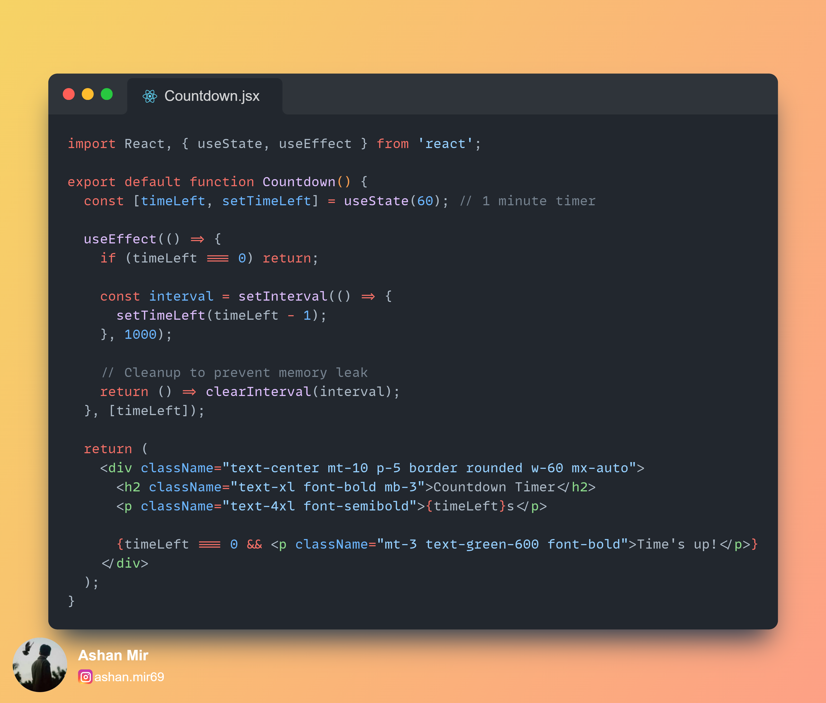

Output:
